LAKE MARGRETHE PROPERTY OWNERS ASSOCIATION
GENERAL MEMBERSHIP MEETING
October 8, 2011
9:00 A.M. – GRAYLING TOWNSHIP HALL

Directors in attendance: Joe Porter, Chuck Spencer, Marshall Roe, Doug Dodge, Sandra Michalik RJ Hannan and Harry Wojcik.
Director not in attendance: Charlotte Bloomquist and Morrie Stevens

Meeting called to Order at about 9:00AM by President Spencer. Total attendance: 18 members and one quest.

WELCOME & INTRODUCTION: Directors, Members and Guests were introduced.

LMPOA OBJECTIVES: Spencer recited the five Association objectives.

MINUTES: Membership Meeting Minutes of July 16, 2011 were not discussed or approved.

TREASURER’S REPORT: Spencer reported a balance in the association’s band account of $8,758.15.

SECRETARY’s REPORT: Roe reviewed membership communication process and a list of 87 members who have not yet provided their e-mail addresses. Also discussed the new LMPOA web site and urged members to become involved in the early phase of development by submission of comments

MEMBERSHIP & EVENTS:
- Hannan reported 252 paid members.
- Reviewed plan to conduct a dinner show at the Camp Grayling Officers’ Club on June 23, 2011. .
- Hannan and Wojcik reported the 2012 LMPOA fishing derby be held on June 9, 2012 with the Camp Graying beach being the registration and weigh-in area.

OLD BUSINESS:
- CLEAR CUTTING OF OAK FOREST IN THE HILLS WEST OF THE LAKE: Susan Theil, Grayling Forest Management Unit, MDNR, presented a thorough review of her responsibility for the almost 300,000 acres of forest in the Crawford County area.
- After her presentation and Q & A she distributed the attached map of the lake area showing (in lavender) the area harvested in the hills west of the lake. She also provided the attached common questions and answers about forest management in our area.
- Her contact information: 989-348-6371 thiels1@michigan.gov
- MILFOIL REMEDIATION: Michalik and Bingert reported that a number of “hot spots” have been mapped and the committee will be seeking a DEQ permit at a cost of $400 to allow chemicals to be applied in total lake bottom area of 19 acres. This will be our first application of chemicals for two years. Michalik also reported she will be looking into a piece of equipment used by other lakes to vacuum up the milfoil weeds and thereby subvert the use of harsh chemicals.
- LAKE MARGRETHE FOUNDATION: Porter provided a complete financial report of the status of the Lake Margrethe Foundation Fund, part of the North Central Michigan Community Foundation. He also provided an explanation of the potential tax benefits to the donor.
  - Established November 10, 1998 with a gift from the LMPOA.
  - The foundation has 40 members contributing at least $750 to the endowment.
  - Endowed funds stand at $96,694.91
  - Contributions also are made for specific purposes, such as Milfoil Remediation. These contributions come from property owners, as well as local government and the US. Army and only may be used for the purpose for which they were given. Donations and grants of this type total over $40,000.
- WHY LITTER CAMPAIGN: Wojcik showed the “Why Litter” signs displayed at 10 strategic locations around the lake. Anecdotal information suggests that the campaign is getting the attention of the lake community.
- LAKE WATER LEVEL: Porter reported the lake water level is about ¼ inch high and that the level has been successfully managed all summer by the adjustment of Portage Creek dam boards.
- E-COLI TESTING: Spencer reports the samples taken from several key points around the lake show no reason for concern or change from prior years.

NEW BUSINESS:
- LMPOA BYLAW REVIEW COMMITTEE: Porter reported that the bylaw review committee has completed its work and has made recommendations to the board of directors, which were approved. The next step will be having the recommended changes ratified by the membership in May 2012. Porter then went through a detailed review of the board-approved recommendations. The revisions will be posted to the web site for member information prior to the schedule member approval.
- SPECIAL AWARD: Spencer report that Bill Moore will receive a plaque indicating the gratitude of the association for his Ph testing of the lake water surface for more than 10 years. Because of Bill we are confident Lake Margrethe’s water is not being affected by possible acid rain.
- 2012 BOAT PARADE: Dodge reviewed concept of renewing the traditional boat parade with certain modifications eliminating the need for liability insurance. The proposed event would occur on July 4, 2012. Boat decoration would be optional, but there would be prizes for those judged best-on-the-lake. The program would start from the M72 area of the lake at about 2:00 PM.

Meeting adjourned at 10:45 am.
Respectfully submitted,
Marshall Roe
Secretary
.

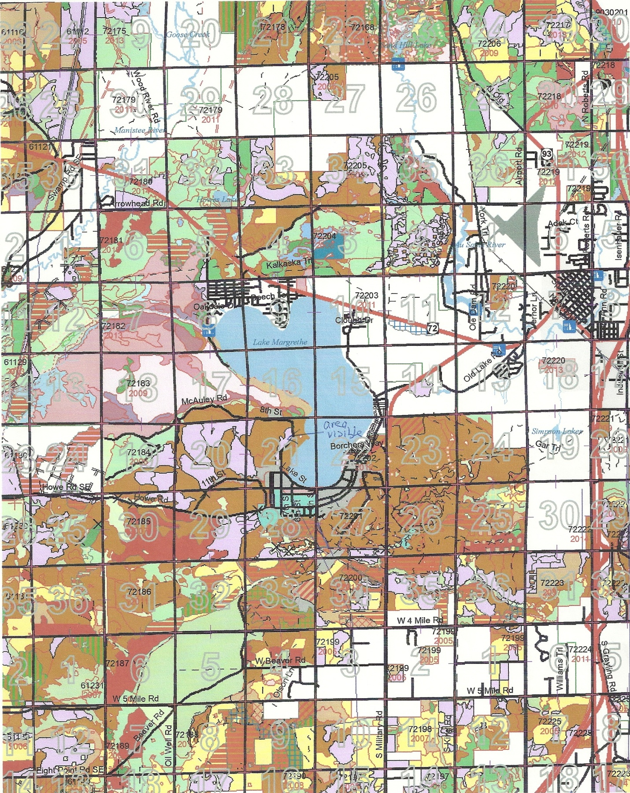

Solid red active or open harvest. Lavender are completed harvests.

