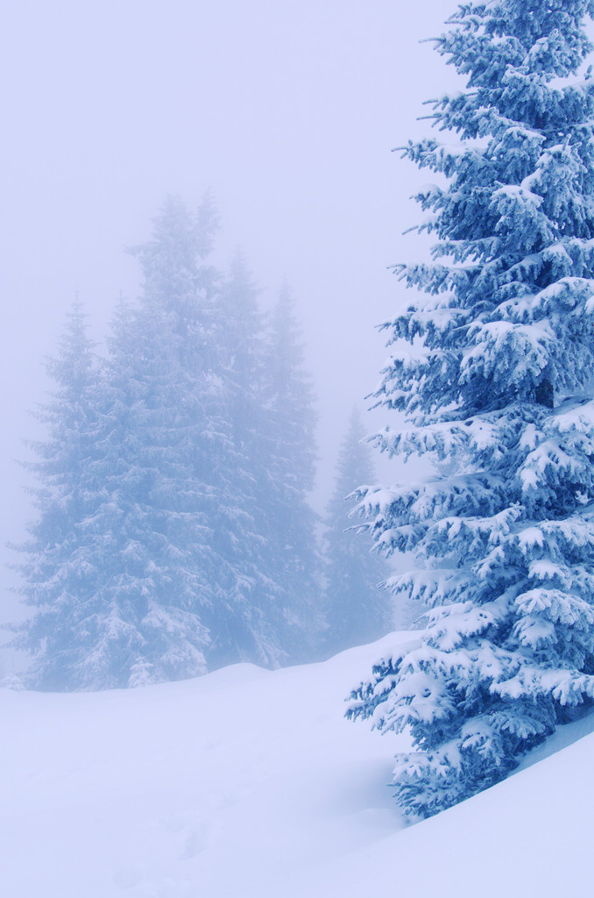
Lake Margrethe

She sparkles in the morning light,
Her Surface shines with diamonds bright.
She’s more serene, when day is done,
Reflecting last rays of the sun.

Her beauty’s there for all to see,
Her wooded shores stretch endlessly.
Thick cover for the hawk and owl,
Safe haven for the waterfowl.

Tall tales about her have come forth —
Our gentle Lady of the North.
So many lives she’s touched through time —
This “jewel” set down among the pine.

Here, Indians once made their home,
Her pristine setting theirs alone.
Her waters offered fish and game,
Her bounty never seemed to wane.

Trapper and traders, passing through —
All waterways these woodsmen knew.
The portage of their goods and stores
Would lead them to her friendly shores.

For “Portage Lake” she had been named,
Before the wilderness was tamed.
Historically, her place she takes
As “gateway to the Greater Lakes”.

Time has a way of fading “fame”,
But Lake Margrethe remains the same.
Now, steeped in history she lies,
Her ageless spirit never dies.

Joan Dickerson-Peters
Reprinted with the permission of the author who resides in the Grayling area
and is 92 years young.

